Town of Mountain Park Regular Meeting
515 N Hwy 183 (Community Building)
Monday, June 12, 2023 @ 7:00 PM

All items on this agenda, including but not limited to any agenda item concerning the adoption of any ordinance, resolution, contract, agreement, or any other item of business, are subject to amendment, including additions and/or deletions. This rule will apply to every individual agenda item with exception, and without providing this same amendment language with respect to each individual agenda item. Such amendments should be rationally related to the topic on the agenda item, or the governing body will be advised to continue the item. The governing body may adopt, approve, ratify, deny, defer, recommend, amend, strike, or continue any agenda item. When more information is needed to act on an item, the governing body may refer the matter to its Town/Trust Manager, staff, attorney or to the recommending board, commission or committee.

- Roll call, Declaration of quorum being present.
- Consider, discuss, and take possible action on Minutes for the May 8, 2023, regular meeting.
- Consider, discuss and take possible action for Special meeting minutes May 18,2023
- Consider, discuss, and take possible action on Encumbrances May/June
- Consider, discuss, and take possible action on May Treasurer’s Report
- Consider, discuss, and take possible action on Budget Message FY Ending 2023
- Consider, discuss, and take possible action on General Fund 2024 Budget
- Consider, discuss, and take possible action on General Fund Budget Amendment #1,2,3,4,5,6,7, & 8
- Consider, discuss, and take possible action on Fire Department 2024 Budget
- Consider, discuss, and take possible action on Fire Department Budget Amendments #1,2, & 3
- Consider, discuss, and take possible action on Street & Alley 2024 Budget
- Consider, discuss, and take possible action on Street & Alley Budget Amendment #1
- Reports from officers and boards
  - Fire Chief, Denton Ervin
- Fire activity
  - Police Chief, Thomas Gibbons
- Citation reports
- Consider, discuss, and take possible action on Close Out Document from SWODA for fire truck
- Consider, discuss, and take possible action on Affidavit Certifying REAP Project Completion
- Consider, discuss, and take possible action on approving purchase orders Fire Department, Street & Alley and General Fund
- Consider, discuss, and take possible action on final contract with Snyder Public Schools OK-38-I004-38-I004-105 to purchase the real property and improvements commonly referenced as the Mountain Park Community Building
- Consider, discuss, and take possible action on Abstract Authorization for the sale of the Community Building
- Consider, discuss, and take possible action to accept bids for the wood chipper
7. Comments from Trustees’
13. Adjourn

Posted in the Office of the City Hall on Friday, June 9, 2023 @ 4:00 PM

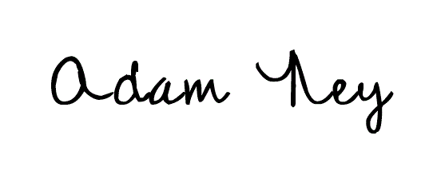
Adam Ney, Mayor

